**2 - Amaliy topshiriq**

*Iqbolshoh Ilhomjonov*

1. Viloyat nomli sinf yarating. Tarkibida 2 ta metod, 4 ta xossa, 2 ta konstruktor, 1 ta destruktor bo’lsin

#include <iostream>

using namespace std;

class Viloyat

{

private:

    string nom;

    int maydoni;

    int aholiSoni;

    int tumanSoni;

public:

    Viloyat() : nom(""), maydoni(0), aholiSoni(0), tumanSoni(0) {}

    ~Viloyat()

    {

        cout << nom << " objekti o'chirib tashlandi " << endl;

    }

    void Set(string a, int b, int c, int d)

    {

        nom = a;

        maydoni = b;

        aholiSoni = c;

        tumanSoni = d;

    }

    void Print()

    {

        cout << " 1) Viloyat nomi: " << nom << endl;

        cout << " 2) Maydoni: " << maydoni << endl;

        cout << " 3) Aholi soni: " << aholiSoni << endl;

        cout << " 4) Tumanlar soni: " << tumanSoni << endl;

        cout << endl;

    }

};

int main()

{

    Viloyat obj1, obj2;

    obj1.Set("Samarqand", 120, 4500000, 14);

    obj2.Set("Toshkent", 350, 40000000, 15);

    obj1.Print();

    obj2.Print();

    return 0;

}

// Natija :

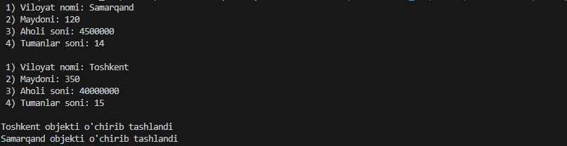

1. Futbol komandasi nomli sinf yarating. Tarkibida 2 ta metod, 4 ta xossa, 2 ta konstruktor, 1 ta destruktor bo’lsin

#include <iostream>

using namespace std;

class Fudbol

{

private:

    string StadionNomi;

    int JamoaSoni;

    int muxlislarSoni;

    string golibJamoa;

public:

    Fudbol() : StadionNomi(""), JamoaSoni(0), muxlislarSoni(0), golibJamoa("") {}

    ~Fudbol()

    {

        cout << StadionNomi << " objekti o'chirib tashlandi " << endl;

    }

    void Set(string a, int b, int c, string d)

    {

        StadionNomi = a;

        JamoaSoni = b;

        muxlislarSoni = c;

        golibJamoa = d;

    }

    void Print()

    {

        cout << " 1) Stadion nomi: " << StadionNomi << endl;

        cout << " 2) Jamoa Soni: " << JamoaSoni << endl;

        cout << " 3) Muxlislar Soni: " << muxlislarSoni << endl;

        cout << " 4) golib Jamoa: " << golibJamoa << endl;

        cout << endl;

    }

};

int main()

{

    Fudbol obj1, obj2;

    obj1.Set("Rungrado", 12, 4500, "real madrid");

    obj2.Set("Salt Lake", 11, 4000, "real madrid");

    obj1.Print();

    obj2.Print();

    return 0;

}

// Natija :

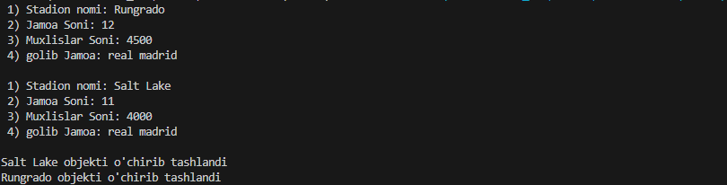

1. Dekanat nomli sinf yarating. Tarkibida 2 ta metod, 4 ta xossa, 2 ta konstruktor, 1 ta destruktor bo’lsin

#include <iostream>

using namespace std;

class Dekanat

{

private:

    string Fakultet;

    string Dekan;

    int zamdekansoni;

    int talabalarSoni;

public:

    Dekanat() : Fakultet(""), Dekan(""), zamdekansoni(0), talabalarSoni(0) {}

    ~Dekanat()

    {

        cout << Fakultet << " objekti o'chirib tashlandi " << endl;

    }

    void Set(string a, string b, int c, int d)

    {

        Fakultet = a;

        Dekan = b;

        zamdekansoni = c;

        talabalarSoni = d;

    }

    void Print()

    {

        cout << " 1) Fakultet nomi: " << Fakultet << endl;

        cout << " 2) Dekan: " << Dekan << endl;

        cout << " 3) Zamdekanlar Soni: " << zamdekansoni << endl;

        cout << " 4) Talabalar Soni: " << talabalarSoni << endl;

        cout << endl;

    }

};

int main()

{

    Dekanat obj1, obj2;

    obj1.Set("Matematika", "Iqbolshoh", 5, 3000);

    obj2.Set("Iqtisodiyot", "Azizjon", 4, 2500);

    obj1.Print();

    obj2.Print();

    return 0;

}

// Natija :

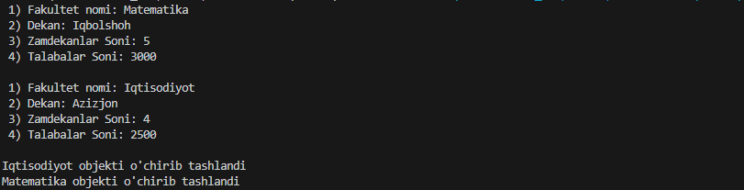

1. Shifoxona nomli sinf yarating. Tarkibida 2 ta metod, 4 ta xossa, 2 ta konstruktor, 1 ta destruktor bo’lsin

#include <iostream>

using namespace std;

class Shifoxona

{

private:

    string nom;

    string manzil;

    string xizmatTuri;

    int ishchiSoni;

public:

    Shifoxona() : nom(""), manzil(""), xizmatTuri(""), ishchiSoni(0) {}

    ~Shifoxona()

    {

        cout << nom << " objekti o'chirib tashlandi " << endl;

    }

    void Set(string a, string b, string c, int d)

    {

        nom = a;

        manzil = b;

        xizmatTuri = c;

        ishchiSoni = d;

    }

    void Print()

    {

        cout << " 1) Shifoxona nomi: " << nom << endl;

        cout << " 2) Manzil: " << manzil << endl;

        cout << " 3) Xizmat turi: " << xizmatTuri << endl;

        cout << " 4) Ishchilar soni: " << ishchiSoni << endl;

        cout << endl;

    }

};

int main()

{

    Shifoxona obj1, obj2;

    obj1.Set("Tibbiyot shifoxonasi", "Toshkent, Amir Temur kochasi", "Tibbiy xizmat", 50);

    obj2.Set("Tibbiyot shifoxonasi", "Samarqand, Seliskiy", "Tibbiy xizmat", 70);

    obj1.Print();

    obj2.Print();

    return 0;

}

// Natija :

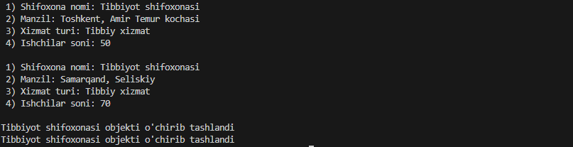

1. GeometrikShakl nomli sinf yarating. Tarkibida 2 ta metod, 4 ta xossa, 2 ta konstruktor, 1 ta destruktor bo’lsin

#include <iostream>

using namespace std;

class Shakl

{

private:

    string shaklnomi;

    int yuzasi;

    string rangi;

    int soni;

public:

    Shakl() : shaklnomi(""), yuzasi(0), rangi(""), soni(0) {}

    ~Shakl()

    {

        cout << shaklnomi << " objekti o'chirib tashlandi " << endl;

    }

    void Set(string a, int b, string c, int d)

    {

        shaklnomi = a;

        yuzasi = b;

        rangi = c;

        soni = d;

    }

    void Print()

    {

        cout << " 1) Shakl nomi: " << shaklnomi << endl;

        cout << " 2) Yuzasi: " << yuzasi << endl;

        cout << " 3) Rangi: " << rangi << endl;

        cout << " 4) Soni: " << soni << endl;

        cout << endl;

    }

};

int main()

{

    Shakl obj1, obj2;

    obj1.Set("Uchburchak", 15, "qizil", 14);

    obj2.Set("To'rtburchak", 20, "ko'k", 7);

    obj1.Print();

    obj2.Print();

    return 0;

}

// Natija :

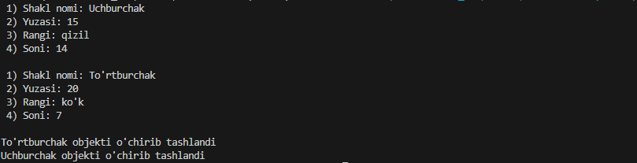

1. Soat nomli sinf yarating. Tarkibida 2 ta metod, 4 ta xossa, 2 ta konstruktor, 1 ta destruktor bo’lsin

#include <iostream>

using namespace std;

class Shakl

{

private:

    string brendi;

    int narxi;

    string turi;

    string rangi;

public:

    Shakl() : brendi(""), narxi(0), turi(""), rangi("") {}

    ~Shakl()

    {

        cout << brendi << " objekti o'chirib tashlandi " << endl;

    }

    void Set(string a, int b, string c, string d)

    {

        brendi = a;

        narxi = b;

        turi = c;

        rangi = d;

    }

    void Print()

    {

        cout << " 1) Brendi: " << brendi << endl;

        cout << " 2) Narxi: " << narxi << endl;

        cout << " 3) Turi: " << turi << endl;

        cout << " 4) Rangi: " << rangi << endl;

        cout << endl;

    }

};

int main()

{

    Shakl obj1, obj2;

    obj1.Set("Rolex", 15000, "qo'l soat", "black");

    obj2.Set("Jacob", 20000, "qo'l soat", "space gray");

    obj1.Print();

    obj2.Print();

    return 0;

}

// Natija :

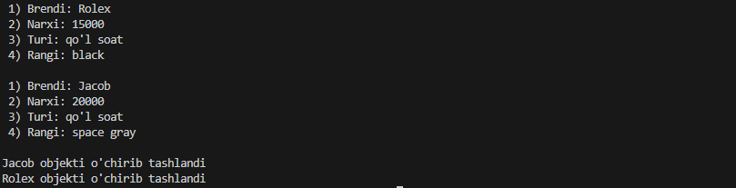

1. Telefon nomli sinf yarating. Tarkibida 2 ta metod, 4 ta xossa, 2 ta konstruktor, 1 ta destruktor bo’lsin

#include <iostream>

using namespace std;

class Telefon

{

private:

    string brendi;

    int narxi;

    string nomi;

    string rangi;

public:

    Telefon() : brendi(""), narxi(0), nomi(""), rangi("") {}

    ~Telefon()

    {

        cout << brendi << " objekti o'chirib tashlandi " << endl;

    }

    void Set(string a, int b, string c, string d)

    {

        brendi = a;

        narxi = b;

        nomi = c;

        rangi = d;

    }

    void Print()

    {

        cout << " 1) Brendi: " << brendi << endl;

        cout << " 2) Narxi: " << narxi << endl;

        cout << " 3) Nomi: " << nomi << endl;

        cout << " 4) Rangi: " << rangi << endl;

        cout << endl;

    }

};

int main()

{

    Telefon obj1, obj2;

    obj1.Set("Iphone", 1200, "15 pro", "space gray");

    obj2.Set("Samsung", 1000, "S 23 ultra", "black");

    obj1.Print();

    obj2.Print();

    return 0;

}

// Natija :

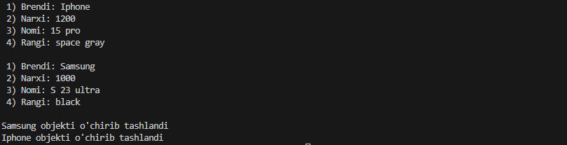

1. Mashina nomli sinf yarating. Tarkibida 2 ta metod, 4 ta xossa, 2 ta konstruktor, 1 ta destruktor bo’lsin

#include <iostream>

using namespace std;

class Mashina

{

private:

    string brendi;

    int narxi;

    string nomi;

    string rangi;

public:

    Mashina() : brendi(""), narxi(0), nomi(""), rangi("") {}

    ~Mashina()

    {

        cout << brendi << " objekti o'chirib tashlandi " << endl;

    }

    void Set(string a, int b, string c, string d)

    {

        brendi = a;

        narxi = b;

        nomi = c;

        rangi = d;

    }

    void Print()

    {

        cout << " 1) Brendi: " << brendi << endl;

        cout << " 2) Narxi: " << narxi << endl;

        cout << " 3) Nomi: " << nomi << endl;

        cout << " 4) Rangi: " << rangi << endl;

        cout << endl;

    }

};

int main()

{

    Mashina obj1, obj2;

    obj1.Set("Tesla", 75000, "Model S", "black");

    obj2.Set("BYD", 60000, "Xan", "black");

    obj1.Print();

    obj2.Print();

    return 0;

}

// Natija :

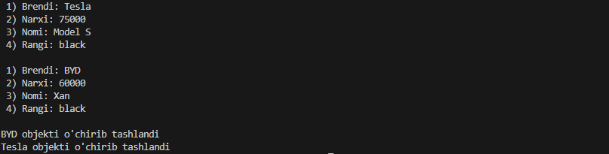

1. Talaba nomli sinf yarating. Tarkibida 2 ta metod, 4 ta xossa, 2 ta konstruktor, 1 ta destruktor bo’lsin

#include <iostream>

using namespace std;

class Talaba

{

private:

    string nomi;

    string familya;

    int yosh;

    string guruh;

public:

    Talaba() : nomi(""), familya(""), yosh(0), guruh("") {}

    ~Talaba()

    {

        cout << nomi << " objekti o'chirib tashlandi " << endl;

    }

    void Set(string a, string b, int c, string d)

    {

        nomi = a;

        familya = b;

        yosh = c;

        guruh = d;

    }

    void Print()

    {

        cout << " 1) Ism: " << nomi << endl;

        cout << " 2) Familya: " << familya << endl;

        cout << " 3) Yoshi: " << yosh << endl;

        cout << " 4) Guruh: " << guruh << endl;

        cout << endl;

    }

};

int main()

{

    Talaba obj1, obj2;

    obj1.Set("Iqbolshoh", "Ilhomjonov", 18, "204");

    obj2.Set("Davlat", "Farruxov", 19, "204");

    obj1.Print();

    obj2.Print();

    return 0;

}

// Natija :

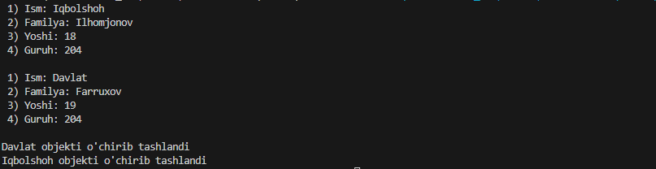

1. Universitet nomli sinf yarating. Tarkibida 2 ta metod, 4 ta xossa, 2 ta konstruktor, 1 ta destruktor bo’lsin

#include <iostream>

using namespace std;

class Universitet

{

private:

    string name;

    string adres;

    int fakultet;

    int students;

public:

    Universitet() : name(""), adres(""), fakultet(0), students(0) {}

    ~Universitet()

    {

        cout << name << " objekti o'chirib tashlandi " << endl;

    }

    void Set(string a, string b, int c, int d)

    {

        name = a;

        adres = b;

        fakultet = c;

        students = d;

    }

    void Print()

    {

        cout << " 1) Nomi: " << name << endl;

        cout << " 2) Adres: " << adres << endl;

        cout << " 3) Fakultet: " << fakultet << endl;

        cout << " 4) Students: " << students << endl;

        cout << endl;

    }

};

int main()

{

    Universitet obj1, obj2;

    obj1.Set("SamDU", "Samarqand", 14, 28000);

    obj2.Set("Milliy", "Toshkent", 16, 32000);

    obj1.Print();

    obj2.Print();

    return 0;

}

// Natija :

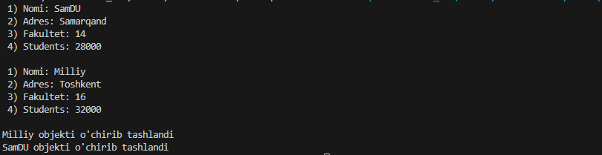

1. Kafedra nomli sinf yarating. Tarkibida 2 ta metod, 5 ta xossa, 2 ta konstruktor, 1 ta destruktor bo’lsin

#include <iostream>

using namespace std;

class Kafedra

{

private:

    string name;

    string fakultet;

    int subjekts;

    int teachers;

    int groups;

public:

    Kafedra() : name(""), fakultet(""), subjekts(0), teachers(0), groups(0) {}

    ~Kafedra()

    {

        cout << name << " objekti o'chirib tashlandi " << endl;

    }

    void Set(string a, string b, int c, int d, int e)

    {

        name = a;

        fakultet = b;

        subjekts = c;

        teachers = d;

        groups = e;

    }

    void Print()

    {

        cout << " 1) Nomi: " << name << endl;

        cout << " 2) Fakultet: " << fakultet << endl;

        cout << " 3) Fanlar: " << subjekts << endl;

        cout << " 4) Teachers: " << teachers << endl;

        cout << " 5) Groups: " << groups << endl;

        cout << endl;

    }

};

int main()

{

    Kafedra obj1, obj2;

    obj1.Set("Dasturiy injinering", "Intelektual T.", 17, 23, 35);

    obj2.Set("Kompyuter Ilmlari", "Intelektual T.", 14, 19, 28);

    obj1.Print();

    obj2.Print();

    return 0;

}

// Natija :

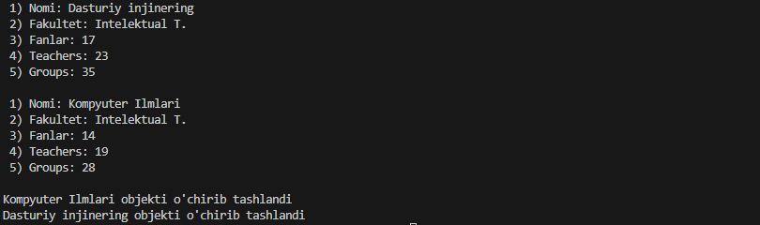

1. Maktab nomli sinf yarating. Tarkibida 2 ta metod, 5 ta xossa, 2 ta konstruktor, 1 ta destruktor bo’lsin

#include <iostream>

using namespace std;

class Maktab

{

private:

    string name;

    string adres;

    int subjekts;

    int teachers;

    int students;

public:

    Maktab() : name(""), adres(""), subjekts(0), teachers(0), students(0) {}

    ~Maktab()

    {

        cout << name << " objekti o'chirib tashlandi " << endl;

    }

    void Set(string a, string b, int c, int d, int e)

    {

        name = a;

        adres = b;

        subjekts = c;

        teachers = d;

        students = e;

    }

    void Print()

    {

        cout << " 1) Nomi: " << name << endl;

        cout << " 2) Manzil: " << adres << endl;

        cout << " 3) Fanlar: " << subjekts << endl;

        cout << " 4) Teachers: " << teachers << endl;

        cout << " 5) Students: " << students << endl;

        cout << endl;

    }

};

int main()

{

    Maktab obj1, obj2;

    obj1.Set("33 - IDUM", "Samarqand tuman", 17, 77, 1435);

    obj2.Set("45 - Maktab", "Samarqand tuman", 17, 55, 957);

    obj1.Print();

    obj2.Print();

    return 0;

}

// Natija :

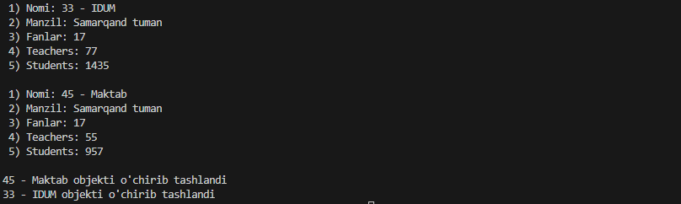

1. Kitob nomli sinf yarating. Tarkibida 2 ta metod, 3 ta xossa, 2 ta konstruktor, 1 ta destruktor bo’lsin

#include <iostream>

using namespace std;

class Kitob

{

private:

    string name;

    string author;

    int reader;

public:

    Kitob() : name(""), author(""), reader(0) {}

    ~Kitob()

    {

        cout << name << " objekti o'chirib tashlandi " << endl;

    }

    void Set(string a, string b, int c)

    {

        name = a;

        author = b;

        reader = c;

    }

    void Print()

    {

        cout << " 1) Nomi: " << name << endl;

        cout << " 2) Muallif: " << author << endl;

        cout << " 3) Kitobxonlar: " << reader << endl;

        cout << endl;

    }

};

int main()

{

    Kitob obj1, obj2;

    obj1.Set("Atom odatlar", "Jems Klir", 57420);

    obj2.Set("Ikki eshik orasi", "Utkir Hoshimov", 25330);

    obj1.Print();

    obj2.Print();

    return 0;

}

// Natija :

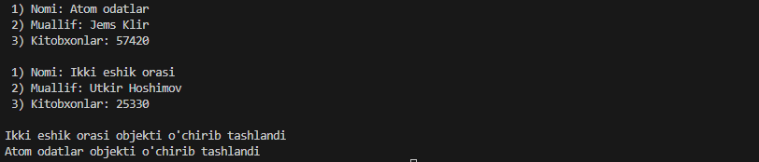

1. Noutbuk nomli sinf yarating. Tarkibida 1 ta metod, 3 ta xossa, 2 ta konstruktor, 1 ta destruktor bo’lsin

#include <iostream>

using namespace std;

class Noutbuk

{

private:

    string brend;

    string name;

    int prise;

public:

    Noutbuk() : brend(""), name(""), prise(0) {}

    ~Noutbuk()

    {

        cout << brend << " objekti o'chirib tashlandi " << endl;

    }

    void Set(string a, string b, int c)

    {

        brend = a;

        name = b;

        prise = c;

    }

    void Print()

    {

        cout << " 1) Berndi: " << brend << endl;

        cout << " 2) Nomi: " << name << endl;

        cout << " 3) Narxi: " << prise << "$" << endl;

        cout << endl;

    }

};

int main()

{

    Noutbuk obj1, obj2;

    obj1.Set("Apple", "Macbook", 1800);

    obj2.Set("Lenovo", "Tab 7", 800);

    obj1.Print();

    obj2.Print();

    return 0;

}

// Natija :

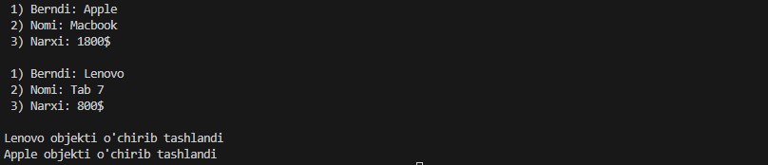

1. Fakultet nomli sinf yarating. Tarkibida 1 ta metod, 3 ta xossa, 2 ta konstruktor, 1 ta destruktor bo’lsin

#include <iostream>

using namespace std;

class Fakultet

{

private:

    string name;

    int kafedra;

    int students;

public:

    Fakultet() : name(""), kafedra(0), students(0) {}

    ~Fakultet()

    {

        cout << name << " objekti o'chirib tashlandi " << endl;

    }

    void Set(string a, int b, int c)

    {

        name = a;

        kafedra = b;

        students = c;

    }

    void Print()

    {

        cout << " 1) Nomi: " << name << endl;

        cout << " 2) Kafedra: " << kafedra << endl;

        cout << " 3) Studentlar: " << students << endl;

        cout << endl;

    }

};

int main()

{

    Fakultet obj1, obj2;

    obj1.Set("Intelektual T.", 3, 770);

    obj2.Set("Matematika", 5, 2500);

    obj1.Print();

    obj2.Print();

    return 0;

}

// Natija :

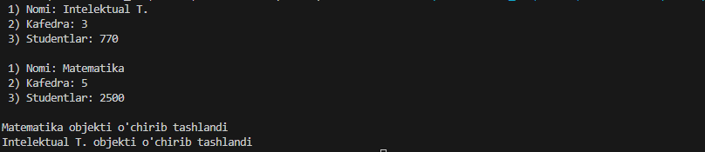

1. Guruh nomli sinf yarating. Tarkibida 2 ta metod, 3 ta xossa, 2 ta konstruktor, 1 ta destruktor bo’lsin

#include <iostream>

using namespace std;

class Fakultet

{

private:

    string name;

    int kurs;

    int students;

public:

    Fakultet() : name(""), kurs(0), students(0) {}

    ~Fakultet()

    {

        cout << name << " objekti o'chirib tashlandi " << endl;

    }

    void Set(string a, int b, int c)

    {

        name = a;

        kurs = b;

        students = c;

    }

    void Print()

    {

        cout << " 1) Nomi: " << name << endl;

        cout << " 2) Kurs: " << kurs << endl;

        cout << " 3) Studentlar: " << students << endl;

        cout << endl;

    }

};

int main()

{

    Fakultet obj1, obj2;

    obj1.Set("204", 2, 27);

    obj2.Set("203", 2, 25);

    obj1.Print();

    obj2.Print();

    return 0;

}

// Natija :

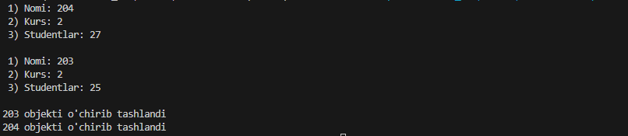

1. Kutubxona nomli sinf yarating. Tarkibida 2 ta metod, 3 ta xossa, 2 ta konstruktor, 1 ta destruktor bo’lsin

#include <iostream>

using namespace std;

class Kutubxona

{

private:

    string name;

    int books;

    int students;

public:

    Kutubxona() : name(""), books(0), students(0) {}

    ~Kutubxona()

    {

        cout << name << " objekti o'chirib tashlandi " << endl;

    }

    void Set(string a, int b, int c)

    {

        name = a;

        books = b;

        students = c;

    }

    void Print()

    {

        cout << " 1) Nomi: " << name << endl;

        cout << " 2) Kitoblar: " << books << endl;

        cout << " 3) Studentlar: " << students << endl;

        cout << endl;

    }

};

int main()

{

    Kutubxona obj1, obj2;

    obj1.Set("Samdu", 1700, 3800);

    obj2.Set("Pushkinski", 1400, 2750);

    obj1.Print();

    obj2.Print();

    return 0;

}

// Natija :

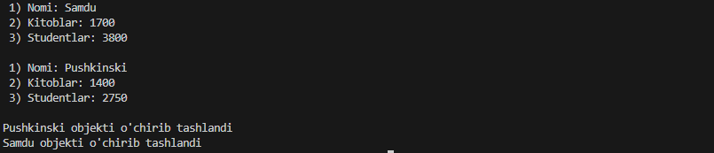

1. Xodim nomli sinf yarating. Tarkibida 2 ta metod, 2 ta xossa, 2 ta konstruktor, 1 ta destruktor bo’lsin

#include <iostream>

using namespace std;

class Xodim

{

private:

    string name;

    int solary;

public:

    Xodim() : name(""), solary(0) {}

    ~Xodim()

    {

        cout << name << " objekti o'chirib tashlandi " << endl;

    }

    void Set(string a, int b)

    {

        name = a;

        solary = b;

    }

    void Print()

    {

        cout << " 1) Nomi: " << name << endl;

        cout << " 2) Maosh: " << solary << "$" << endl;

        cout << endl;

    }

};

int main()

{

    Xodim obj1, obj2;

    obj1.Set("Iqbolshoh", 2500);

    obj2.Set("Azizjon", 1700);

    obj1.Print();

    obj2.Print();

    return 0;

}

// Natija :

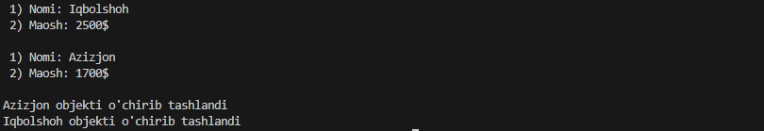

1. Korxona nomli sinf yarating. Tarkibida 2 ta metod, 3 ta xossa, 2 ta konstruktor, 1 ta destruktor bo’lsin

#include <iostream>

using namespace std;

class Korxona

{

private:

    string name;

    int xodim;

    int daromad;

public:

    Korxona() : name(""), xodim(0), daromad(0) {}

    ~Korxona()

    {

        cout << name << " objekti o'chirib tashlandi " << endl;

    }

    void Set(string a, int b, int c)

    {

        name = a;

        xodim = b;

        daromad = c;

    }

    void Print()

    {

        cout << " 1) Nomi: " << name << endl;

        cout << " 2) Xodim: " << xodim << endl;

        cout << " 3) Daromad: " << daromad << "$" << endl;

        cout << endl;

    }

};

int main()

{

    Korxona obj1, obj2;

    obj1.Set("IT-center", 7, 57000);

    obj2.Set("Premium education", 20, 25000);

    obj1.Print();

    obj2.Print();

    return 0;

}

// Natija :

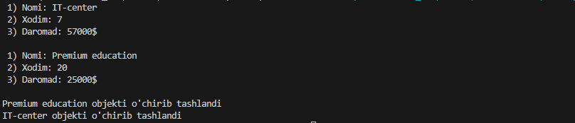

1. Shahar nomli sinf yarating. Tarkibida 2 ta metod, 3 ta xossa, 2 ta konstruktor, 1 ta destruktor bo’lsin

#include <iostream>

using namespace std;

class Shahar

{

private:

    string name;

    int maydoni;

    int aholi;

public:

    Shahar() : name(""), maydoni(0), aholi(0) {}

    ~Shahar()

    {

        cout << name << " objekti o'chirib tashlandi " << endl;

    }

    void Set(string a, int b, int c)

    {

        name = a;

        maydoni = b;

        aholi = c;

    }

    void Print()

    {

        cout << " 1) Nomi: " << name << endl;

        cout << " 2) Maydoni: " << maydoni << " Gektar " << endl;

        cout << " 3) Aholi: " << aholi << endl;

        cout << endl;

    }

};

int main()

{

    Shahar obj1, obj2;

    obj1.Set("Samarqand", 15000, 1750300);

    obj2.Set("Buxoro", 17000, 2507100);

    obj1.Print();

    obj2.Print();

    return 0;

}

// Natija :

